## DS4D Assignment 4

### Zhihan Yang

#### A link to your Github repository and your Github handle

<https://github.com/DS4D-Group16/Assignment3>

#### A screenshot showing the number of commits that you have made - you can find this in the /Contributor/ tab under /Insights/

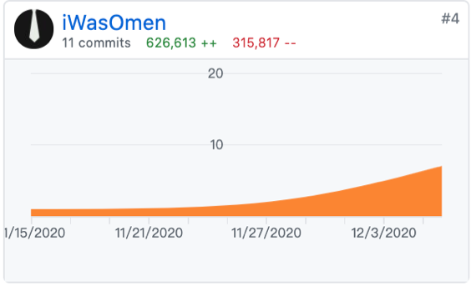

#### A screenshot evidencing good, informative commit messages that you have made

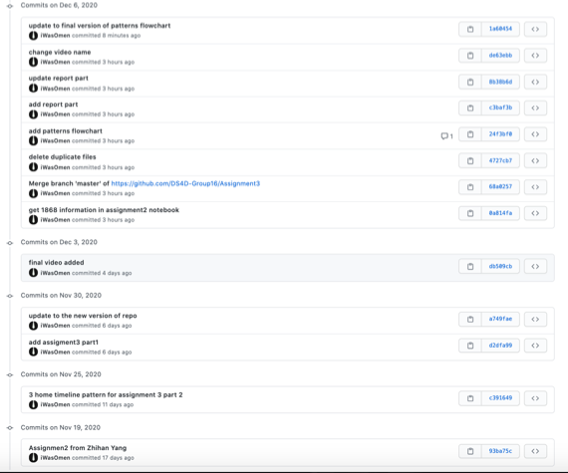

#### A screenshot showing an issue that you created.

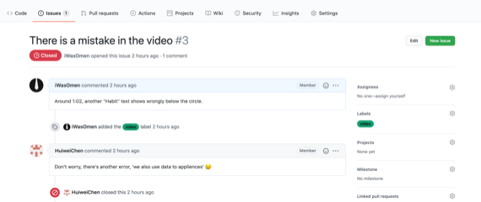

#### A screenshot showing your contribution to discussion on someone else’s issue.

